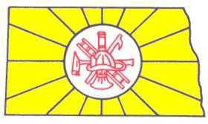
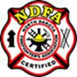

Firefighter II Academy

This academy is designed to provide firefighter knowledge and skills training to prepare firefighters wishing to take the state the Firefighter II level certification test. The academy consists of an online, self-paced, classroom instruction which follows the current Jones and Bartlett Fundamentals of Fire Fighter Skills curriculum. The academy also includes two (2) weekends where candidates are trained on the firefighter Job Performance Requirements (JPRs) identified in NFPA 1001, Standard for Fire Fighter Professional Qualifications.

Candidates who successfully complete this academy are eligible to attempt the certification test. ProBoard® accredited, Firefighter II certification will be awarded to those who successfully pass the testing process and complete all prerequisites.

To request an academy, contact the NDFA office with the following information:
- Number of Students (minimum of 10 required for regionals)
- Location of in-person skills training
- Requested dates of weekends.
- Any equipment needed from the NDFA for this academy
- Names of instructors, if any, who have agreed to instruct
COST:

NDFA identifies only a set amount available to spend on Fire Academies annually and must approve all academy funding requests prior to schedule being approved. Selected departments are limited to one (1) funded academy per fiscal year. Departments may conduct a second academy at their own cost if they so choose.

Requesting departments who do not get approved due to lack of funding will have scheduling priority after the next fiscal year begins.

Course texts books are the students/departments responsibility. NDFA receives a 30% discount from Jones and Bartlett. It is highly recommended that departments/students order texts book from the NDFA.

Access to the online course is included with each textbook purchase.

For students wishing to enroll in a scheduled academy, please contact the NDFA office for further information.

Minimum Student Requirements
- Full PPE
- Self-Contained Breathing Apparatus (SCBA).

